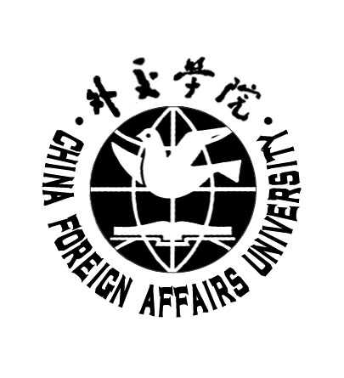
CHINA FOREIGN AFFAIRS UNIVERSITY
24 Zhanlan Road, Beijing 100037, CHINA
Tel/Fax: 86-10-68323316
E-mail: facjwch@cfau.edu.cn

外教证字[2013]

外交学院本科生在校就读证明

兹证明，王某，女，1990年1月1日生，于2009年9月被录取至外交学系外交学系外交学专业 学习，学制4年。将于2013年7月毕业。根据《中华人民共和国学位条例》规定，该生将被授予 法学学士 学位。

外交学院教务处
2013年 3月26日
(2013)W.J.Z.Z.
Mar. 26, 2013
CHINA FOREIGN AFFAIRS UNIVERSITY
UNDERGRADUATE STUDENT CERTIFICATE

This is to certify that Miss Wang Mou, born on Jan. 1st, 1990 is a registered undergraduate student of the four-year full-time program in the Department of Diplomacy, majoring in Diplomacy. The four-year program commenced in September 2009 and is due to end in July 2013. According to the articles of Regulations of the People’s Republic of China on Academic Degrees, this student shall be hereby granted Bachelor’s Degree of Laws.

Official Seal
Academic Affairs Office

China Foreign Affairs University

